

SCHOOL OF MECHANICAL & MANUFACTURING ENGINERRING

NUST

Department of Mechanical Engineering

CS-114 – Fundamentals of Programming

LAB MANUAL #03

**Course Instructor**: Dr Khawaja Fahd Iqbal

**Lab Instructor**: Muhammad Affan

**Student Name**: Muhammad Usman Abdullah

**Section**: B

**CMS ID**: 461513

**DATE**: 17-October-2023

LAB #03 (HOME TASK)

TASK 1:

#include <iostream>

using namespace std;

//Program to print total number of population in Punjab, Sindh, KPK and Balochistan

int main(){

char province;

cout<<"Enter the initial letter of province,(e.g for Punjab enter p)"<<endl;

cin>>province;

switch(province){

case'p':

cout<<"The population of Punjab is 127,474,000";

break;

case's':

cout<<"The population of Sindh is 54,858,515";

break;

case'k':

cout<<"The population of KPK is 39,372,462";

break;

case'b':

cout<<"The population of Balochistan is 20,094,659";

break;

default:

cout<<"Error: Wrong Province Selected";

}

return 0;

}

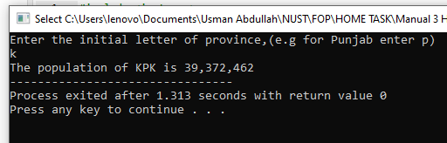

TASK 2:

#include <iostream>

using namespace std;

int main(){

char letter;

cout<<"Enter a letter"<<endl;

cin>>letter;

switch(letter){

case'a':

cout<<"The letter "<<letter<<" is a vowel";

break;

case'e':

cout<<"The letter "<<letter<<" is a vowel";

break;

case'i':

cout<<"The letter "<<letter<<" is a vowel";

break;

case'o':

cout<<"The letter "<<letter<<" is a vowel";

break;

case'u':

cout<<"The letter "<<letter<<" is a vowel";

break;

default:

cout<<"The letter "<<letter<<" is a consonant";

}

return 0;

}

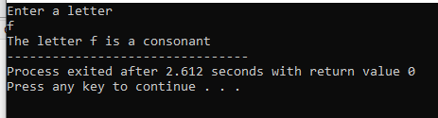

TASK 3:

#include <iostream>

using namespace std;

int main(){

int n,m;

cout<<"Enter a number"<<endl;

cin>>n;

if(n==0){

m=1;

}

else{

if(n>0){

m=2;

}

}

switch(m){

case 1:

cout<<"The number is zero";

break;

case 2:

cout<<"The number is positive";

break;

default:

cout<<"The number is negative";

}

return 0;

}

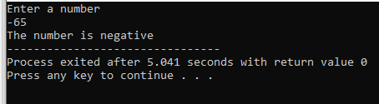

TASK 4:

#include <iostream>

using namespace std;

int main(){

int age;

cout<<"Enter the person's age"<<endl;

cin>>age;

if(age<=12){

cout<<"The person is a child";

}

else{

if(age>12 && age<20){

cout<<"The person is a teenager";

}

else{

cout<<"The person is an adult";

}

}

return 0;

}

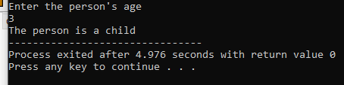

TASK 5:

#include <iostream>

using namespace std;

int main(){

int a,b,c;

cout<<"Enter the first number"<<endl;

cin>>a;

cout<<"Enter the second number"<<endl;

cin>>b;

cout<<"Enter the third number"<<endl;

cin>>c;

if(a>b && a>c){

cout<<a<<" is greatest";

}

else{

if(b>a && b>c){

cout<<b<<" is greatest";

}

else{

cout<<c<<" is greatest";

}

}

return 0;

}

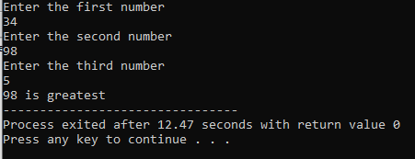

TASK 6:

#include <iostream>

using namespace std;

int main(){

char letter;

cout<<"Enter a letter"<<endl;

cin>>letter;

if(letter=='a'){

cout<<"The letter is a vowel";

}

else{

if(letter=='e'){

cout<<"The letter is a vowel";

}

else{

if(letter=='i'){

cout<<"The letter is a vowel";

}

else{

if(letter=='o'){

cout<<"The letter is a vowel";

}

else{

if(letter=='u'){

cout<<"The letter is a vowel";

}

else{

cout<<"The letter is a consonant";

}

}

}

}

}

return 0;

}

